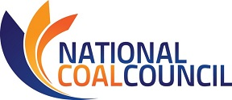
2018 ANNUAL SPRING MEETING
April 11-12, 2018 – The Wink Hotel – Washington, D.C. 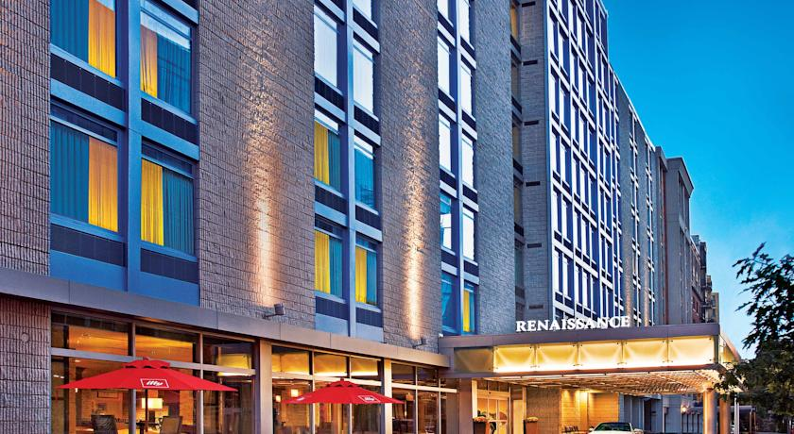
NCC MEETING REGISTRATION
Fax: 732-231-6581 or Email info@NCC1.org this registration form.
Please register for the meeting no later than March 16, 2018
Name:
Title:
Company:
Phone:
Address:
Email Address:
Guest Name(s):
Guest Company & Email:
I will attend the following events:
(You will be invoiced for lunch, dinner, & sponsorships.)

Wednesday, April 11th, 2018
_____ *NCC Inc. Dinner 6:00-9:00 pm $150 individual seat ($75 government employee)
See next page for sponsorship and full table reservations.
Please Note: Counsel has advised that under House and Senate rules, this is a “widely attended event.” Under these rules, only NCC may extend invitations to House or Senate Members or staff to attend this event. Individual members of NCC are not permitted to extend invitations. Please contact the NCC office if you wish us to extend an invitation to Congressional members/staff on your behalf. Violations of these rules may result in criminal liability.

Thursday, April 12th, 2018
_____ NCC Full Council Meeting 8:30 am-12:15 pm
_____ *Plated Lunch 12:15 pm $45

*No refunds after March 28th. Refunds prior to March 28th subject to 5% service fee.*
Attention NCC Members: Travel reimbursement must be received by DOE no later than March 9th, 2018.
Full details of the travel reimbursement policy may be found at
Travel Reimbursement Procedures for Qualifying NCC Members.
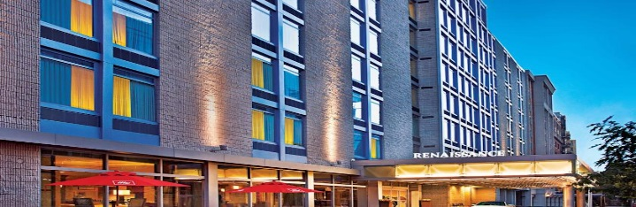
2018 ANNUAL SPRING MEETING
April 11-12, 2018
Washington, D.C.

Hotel Reservations
All events will be hosted at The Wink Hotel, Washington, DC
1143 New Hampshire Avenue NW, Washington, DC 20037
Deluxe guest room rates are $259.00 per night
Reservations must be made by March 16th to secure this rate.
Rooms can be reserved by calling 1-833-588-9465 and requesting
National Coal Council 2018 Spring Meeting
For Online Reservations: http:bookings.ihotelier.com/bookings.jsp?groupID=2100264&hotelID=103690
April 11th NCC Inc. Dinner Sponsorship Opportunities

_____$6000 Platinum Sponsor
- Drinks reception sponsorship.
- One table of eight (8) w/priority seating.
- Corporate logo projected via Gobo.
- Company logo included on sponsorship banner and NCC website.
- Sponsorship acknowledgement on PowerPoint at NCC Full Council Meeting.
- Verbal recognition of sponsorship during dinner and NCC Full Council Meeting.

_____$3500 Gold Sponsor
- Four (4) seats at dinner w/priority seating.
- Company logo on beverage coasters at each place setting.
- Company logo included on sponsorship banner and NCC website.
- Sponsorship acknowledgement on PowerPoint at NCC Full Council Meeting.

_____$2500 Silver Sponsor
- Two (2) seats at dinner w/ priority seating.
- Dessert station sponsorship with company logo signage at dessert table.
- Company logo included on sponsorship banner and NCC website.

_____$1000 Table Sponsor
- One table of eight (8) w/priority seating and company logo displayed at table.

_____$1800 Red Wine Sponsor
- Red wine service for all dinner participants (2 bottles/table).
- Company logo on wine bottle label.

_____$1800 White Wine Sponsor
- White wine service for all dinner participants (2 bottles/table).
- Company logo on wine bottle label.
April 12th NCC Full Council Meeting Sponsorship Opportunities

_____ Event Sponsor (includes Hotel Keycard sponsorship) ~ $2500
_____ Keynote Session Sponsor (special acknowledgement at opening session) ~ $1000
_____ Breakfast ~ $750
_____ Break ~ $500
_____ Coffee Sponsor ~ $500 (Company logo displayed at coffee breaks)
_____ Plated Lunch Sponsor ~ $750

