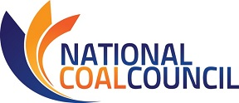

2019 Fall ANNUAL MEETING
September 11-12, 2019 – Marriott Wardman Park Washington, D.C.
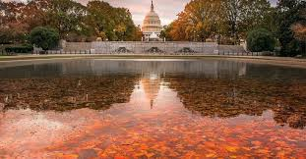
NCC MEETING REGISTRATION
Fax: 732-231-6581 or Email info@NCC1.org this registration form.
Please register for the meeting no later than August 13th, 2019
Name:
Title:
Company:
Phone:
Address:
Email Address:
Guest Name(s):
Guest Company & Email:

I will attend the following events ~ Note: You will be invoiced for lunch, dinner, & sponsorships.

Wednesday, September 11th, 2019
_____ *NCC Dinner 6:00-9:00 pm $175 individual seat ($75 government employee)
_____ Please reserve a priority dinner table of 8 for me @ discounted rate of $1200

Note: Counsel has advised that under House and Senate rules, this is a “widely attended event.” Under these rules, only NCC may extend invitations to House or Senate Members or staff to attend this event. Individual members of NCC are not permitted to extend invitations. Please contact the NCC office if you wish us to extend an invitation to Congressional members/staff on your behalf. Violations of these rules may result in criminal liability.
Thursday, September 12th, 2019
_____ NCC Full Council Meeting 8:30 am-12:30 pm
_____ *Buffet Lunch Noon $50

*No refunds after August 28th. Refunds prior to August 28th subject to 5% service fee. *
Attention NCC Members: Travel reimbursement must be received by DOE no later than August 5th, 2019.
Full details of the travel reimbursement policy may be found at
Travel Reimbursement Procedures for Qualifying NCC Members.

September 11th NCC Dinner Sponsorship Opportunities

_____$3000 Coal Rocks Dinner Sponsor
- Acknowledgement as drinks reception sponsor.
- Three (3) seats at dinner w/priority seating.
- Company logo included on sponsorship banner and NCC website.
- Sponsorship acknowledgement on PowerPoint at NCC Full Council Meeting.
- Verbal recognition of sponsorship during dinner and NCC Full Council Meeting.

_____$2000 Coal Rocks Reception Sponsor
- Acknowledgment as reception sponsor.
- Two (2) seats at dinner w/priority seating.
- Company logo included on sponsorship banner and NCC website.
- Sponsorship acknowledgement on PowerPoint at NCC Full Council Meeting.

_____$1000 Coal Rocks Dessert Station Sponsor
- Acknowledgment as dessert station sponsor.
- One (1) seats at dinner w/ priority seating.
- Company logo included on sponsorship banner and NCC website.

September 12th NCC Full Council Meeting Sponsorship Opportunities

_____ Event Sponsor (includes Hotel Keycard sponsorship) ~ $2500
_____ Keynote Session Sponsor (special acknowledgement at opening session) ~ $1000
_____ Breakfast (includes logo signs on breakfast station at Full Council Meeting) ~ $1000
_____ Break/Coffee (includes logo signs on the break station at Full Council Meeting) ~$750
_____ Buffet Lunch Sponsor (includes logo signs on the lunch buffet station) ~ $750
_____ WIFI Sponsorship (Company name featured on NCC Full Council Meeting Welcome PowerPoint) ~ $500

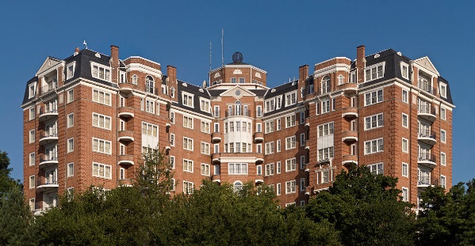
2019 FALL ANNUAL MEETING
September 11-12, 2019 ~ Washington, D.C.

Hotel Reservations
All events will be hosted at Marriott Wardman Park, Washington, DC
2660 Woodley Road NW, Washington, DC 20008
Deluxe guest room rates are $269.00 per night
Reservations must be made by August 13th to secure this rate.
Rooms can be reserved by calling 1-877-212-5752 and requesting
National Coal Council 2019 Fall Meeting
For Online Reservations: https://book.passkey.com/e/49928199

Disclaimers
Photo Release

The National Coal Council, its successors and assigns, retain the right and permission to publish, without charge, photographs taken during this event. These photographs may be used in publications, including electronic publications, or in audio-visual presentations, promotional literature, advertising, or in other similar ways. By attending the event, you agree to the foregoing,

Medical Release

Conference attendees acknowledge and agree that as a result of their registration and participation in the event, they hereby assume responsibility for their own well-being and safety. Attendees assume the risk in taking part in any voluntary off-site activities and attendees, their heirs, assigns and representatives hereby agree to indemnify and release the National Coal Council, its directors, officers, employees and agents from all liability, claims, demands or losses caused, in whole or in part, by attendee’s participation in the event or other activities including third party activities.

